**SEBIN JOSEPH**

*sebin_joseph1992@yahoo.co.in*

*+91 9930184553*

*Skype ID- sebin_joseph1992*



Enthusiastic young professional with 2 years of Experience in FMCG Sales & Distribution line. Currently working as a Territory Sales Executive in Abbott Healthcare Pvt Ltd (Nutrition). Temporarily posted at Raipur HQ for the past 1.5 years handling a SDM position & looking after entire Chhattisgarh territory.

Seeking for opportunities in Marketing/ Brand Management /Client servicing in an organization of high repute providing a highly motivated, progressive & friendly environment encouraging my pursuit of career advancement & expanding my knowledge & Skill.

Location Preference: Mumbai

**AREAS OF EXPERTISE**

* FMCG Sales
* Distribution Management
* Distributor Management ( Pharma & Trade )

C

* Driving Primary & Secondary Sales
* Area & Business Planning
* Branding & In store Merchandising
* Designing POSM elements
* Field Force Management & Development

**PROFESSIONAL EXPERIENCE**

**Territory Sales Executive: Abbott Healthcare Pvt Ltd, May 2015 to Present**

**Responsibilities:**

* Ensure Achievement of monthly, quarterly & annual agreed sales targets within laid out business terms for all brands.
* Monitoring Distributors & Field force at a beat level.
* Identify potential towns & Appoint distributors in line with business strategy
* Formulate & Execute Secondary sales plan- Area wise, Distributor wise, Brand wise, SKU wise weekly and monthly.
* Ensuring quality of market coverage through effective use of ISR’s & distribution network.
* Ensure implementation of Trade & Consumer promotion plans & Support Micro-marketing & Customer Activation initiatives planned for the area.
* Hiring, Training & motivating Field force to get the desired results.
* Data management & Reporting.

**Accomplishments:**

* Significantly brought growth in Primary & Secondary Sales In Chhattisgarh
* Effectively handling a total of 18 distributors all over Chhattisgarh. ( 9 Pharma, 9 Trade & 1 Super Stockist )
* Conceptualized & successfully executed numerous BTL activities in my territory like Designing Posters, Brochures & product detailers for New product launches. Also conducted many taste campaigns & Road shows thereby engaging new customers & increasing Market share in my territory.
* Awarded for the Best execution in In-store visual Merchandising & Branding in West region.
* Developed the markets significantly & improved the retail coverage of Pediasure as a Brand.

**INTERNSHIP**

**Management Trainee: VIP Industries Limited, 2months (Mumbai & Chennai)**

**Project Title-** *‘Mapping VIP Luggage in the Emerging Markets of Chennai’*

**KRA:**

* Study of Dealers/Distributors & Retailers
* Positioning of VIP Luggage
* Counter-share Study
* Market Research in the respective sphere with the help of Business Development Executives & Long Sales Arm Force

**Responsibilities:**

* Identifying of Suburbs in Chennai & Carrying out Market Visits.
* In-depth interviews of luggage retailers and overall market study of competitors & peer brands.
* Studying & understanding Behavioral patterns of the locals & working with the Customer Marketing team and Creative team in formulating Marketing strategies for Tamil Nadu.
* Collection of data using Questionnaires & Photos.
* Analyze data, make conclusions and recommendations, submit a report & give a final presentation.

**EDUCATION:**

* MBA / Masters of Management Studies (MMS) in Marketing : Bharati Vidyapeeth Institute Of Management Studies & Research, Mumbai (2015)
* Bachelor of Commerce (B.Com): Bhavans College, Andheri, Mumbai (2012)
* HSC – Bhavans College, Andheri (2009)
* SSC – Holy Family High School, Andheri (2007)

**COMPUTER KNOWLEDGE:**

* MS Office Word
* MS Excel
* MS PowerPoint
* Adobe Photoshop

Certifications: Certificate Course on Computer Technology (CCCT)

German Language Course (A1)

**EXTRA CURRICULAR ACTIVITIES**

* Was a part of Marketing team of the O2 college Fest held by Bhavans College where I assisted in the Social Media Marketing & PR campaign, helped generating sponsorship leads & also designed various creatives for the event.
* Vice- President and also the WEBCOM Director of the Rotaract club of BVIMSR. (Disrict.3140)
* Worked Closely with parent Rotary Club in making creatives & getting sponsorships for various social events.
* Was part of the managing team in the 25th AIMS Annual Convention held at BVIMSR
* Student Editor of the college (Chief Designer of the College Newsletter ‘INGENIUM’)
* Was in the Organizing committee of an Inter-college fest ‘SHIKHAR’14’ (Creative Head)
* 1st Prize Winner of a Photography competition in the Inter-college fest SHIKHAR’14
* Was a part of the Annual Alumni Meet’14 organizing committee (also designed Invitation cards for over 1500 Alumni and various posters for the event)
* Participated in a Social Film Making Competition conducted by ‘Yes Foundation’
* Organized and designed a Seminar named ‘Brand Mania’ in BVIMSR for strength of 150 students.
* Participated in an Inter-Collegiate Business Quiz Competition held at YMT College, Kharghar
* Played Football for my School and Degree College.

**COMMUNITY SERVICE:**

* Past active member of Rotaract Club of Navi Mumbai.
* Have served as the Vice President of Rotaract Club running under Parent Rotary Club

(RC BVIMSR District 3140)

**STRENGTHS & ATTRIBUTES**

* Strong communication and Interpersonal skills.
* Strong Observational & Analytical Skills
* Pleasing personality, optimistic attitude.
* Keen & Enthusiastic and Quick Learner
* Organized, dedicated and a sincere Professional
* Team Player
* Strong ability to achieve immediate and long-term goals and meet project deadlines.
* Honest, Hardworking & Proactive.
* Leadership Skills
* A creative eye for any challenge.

**PERSONAL DETAILS:**

Date of Birth: 12th May 1992

Address: C-9 I.R.E Apartments, Dr. Charat Singh Colony Road, Chakala, Andheri East

Languages Known: English, Hindi, Marathi, Malayalam, German (Beginner)

Hobbies: Photography, Photo Editing (Photoshop), Listening to Music, Football & Chess

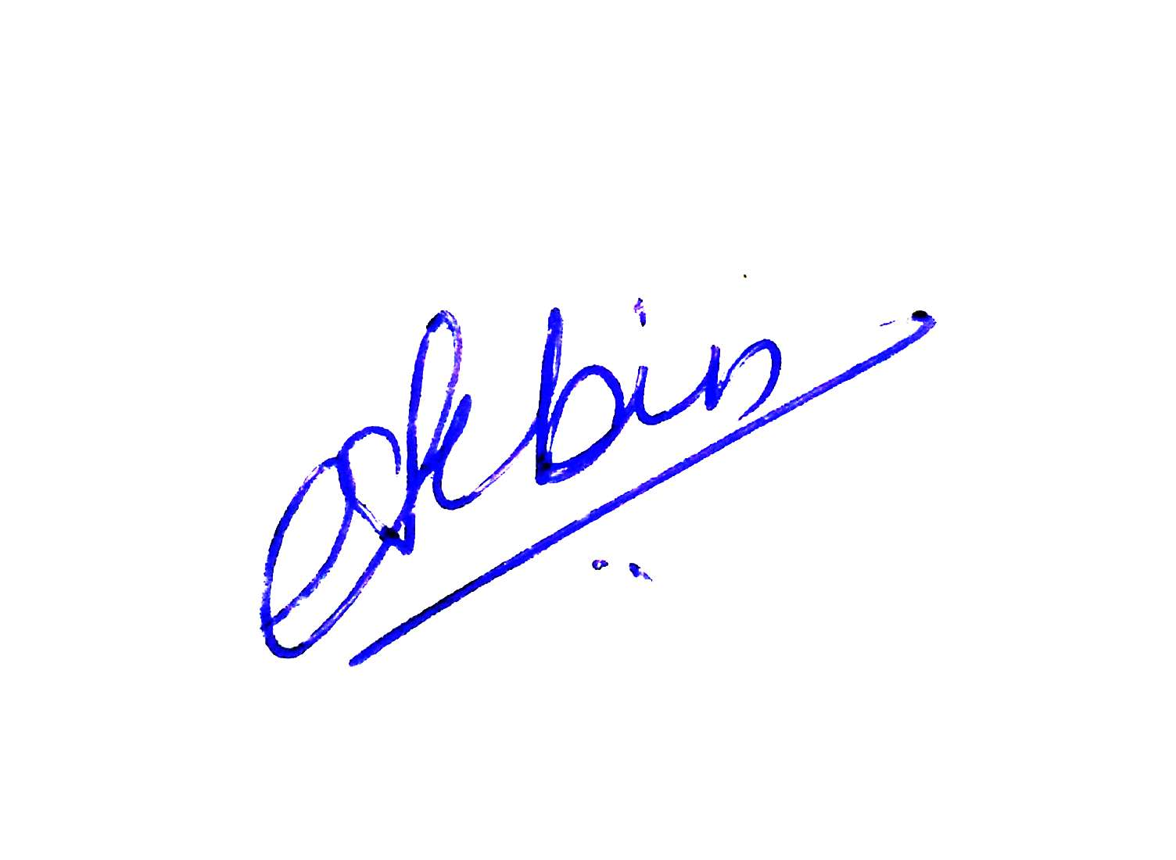

Date:

Place: Mumbai Signature